Ideation Phase
Define the Problem Statements

Date | 23 Jan 2026
Team ID | LTVIP2026TMIDS64924
Project Name | SmartSorting
Maximum Marks | 2 Marks

Customer Problem Statement:
This problem statement outlines the key challenges identified in the fruit and vegetable sorting sector, particularly in small-scale industries. Based on multiple user perspectives—including industry owners, sorting workers, and local vendors—the analysis highlights the most pressing issues related to freshness detection, manual sorting inefficiencies, and quality assurance. These challenges directly impact product consistency, customer satisfaction, and operational cost. Addressing them through affordable, AI-based solutions is essential to improve accuracy, reduce waste, and streamline the sorting process in low-resource environments.
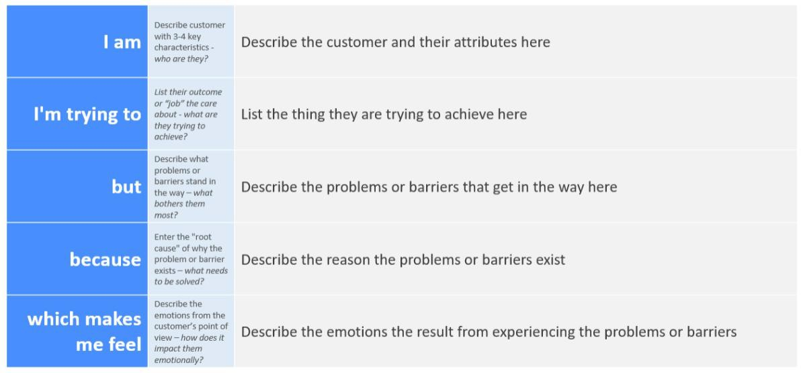
Example:


Problem Statement (PS) | I am (Customer) | I’m trying to | But | Because | Which makes me feel
PS-1 | I am a small-scale fruit and vegetable industry owner who runs a local sorting and packaging unit | I’m trying to automate the process of identifying and separating rotten or spoiled produce | But I can’t afford expensive AI  systems or hire skilled technicia ns to manually sort large  volumes daily | Because my budget and workforce are limited, and manual sorting is inconsistent | Which makes me feel stressed and worried about delivering low-quality products to customers
PS-2 | I am a worker at a small fruit and vegetable processing unit | I’m trying to quickly check each fruit/vegetab le for signs of spoilage | But I often miss subtle signs of rotting or mold due to fatigue and high  volume | Because we sort thousands of items manually every day with little time per item | Which makes me feel frustrated and worried about making mistakes that cost the company money

